ArchivesSpace Spreadsheet Upload Guide at the BYU Library Special Collections

Contents
Template Location 4
Header Row Orientation 4
Limitations of Import Spreadsheet 4
General Spreadsheet Tips 5
Data Format Settings 5
Hiding, Deleting, and Rearranging Columns 6
Reducing Row Sizes 6
Data Validation 6
Specific Field Guidelines 7
Field Name 8
Resource Identifier 8
EAD ID 8
Ref ID 9
Title 9
Component Unique Identifier 10
Hierarchical Relationship 10
Description Level 11
Other Level 12
Publish? 12
Restrictions Apply? 13
Processing Note 14
Dates 14
Dates Label 15
Date Begin and Date End 15
Date Type 16
Date Expression 16
Date Certainty 17
Additional Dates Statements 17
Extents 18
Extent Portion 19
Extent Number 19
Extent Type 20
Container Summary 20
Physical Details 21
Dimensions 21
Additional Extent Statements 22
Instances 23
Container Instance Type 23
Top Container Type 23
Top Container [Indicator] 24
Barcode 24
Child Type 25
Child Indicator 25
Grandchild Type and Grandchild Indicator 26
Additional Instance Statements 26
Digital Object fields 27
Agents 28
People Agents 28
Agent Record ID 29
Agent Header String 29
Agent Role 29
Agent Relator 30
Additional People Agent Links 30
Family Agents 31
Family Agent Record ID 31
Family Agent Header String 32
Family Agent Role 32
Family Agent Relator 33
Additional Family Agent Links 33
Corporate Agents 34
Corporate Agent Record ID 34
Corporate Agent Header String 35
Corporate Agent Role 35
Corporate Agent Relator 35
Additional Corporate Agent Links 36
Subjects 37
Subject Record ID 37
Subject Term 38
Subject Type 38
Subject Source 39
Additional Subject Links 39
Using ASpace genreform terms Spreadsheet 40
Spreadsheet Setup 40
Set up Genre/Form Data Validation 41
Assigning Genre/Form Terms 42
Coding the Record ID, Type, and Source Columns 43
Proofing the Record ID, Type, and Source Columns 50
Copying Subject Metadata to the Import Spreadsheet 50
Before Import 52
Notes 52
Notes Most Commonly Used at the File and Item Level Include: 53
Access Restrictions 53
Biography/History 54
General 54
Language of Materials 55
Scope and Contents 55
Other Notes Commonly Used at Series and Subseries Level: 56
Arrangement 56
Other Notes Not Usually Used in the Import Spreadsheet: 56
Multiple Notes 56
Additional Resources 56
Upload to ArchivesSpace 56

Template Location
Template and examples for spreadsheet located in:
Box\catshare\Archival Processing Section\Spreadsheet training
The template (and instructions for filling it out) is also available on the GitHub page about the import plugin and spreadsheet.

Header Row Orientation
The template includes a blank row at the top to label the spreadsheet. You can leave this line as is or change it to the call number and/or collection title—or anything else you'd like to label the spreadsheet.
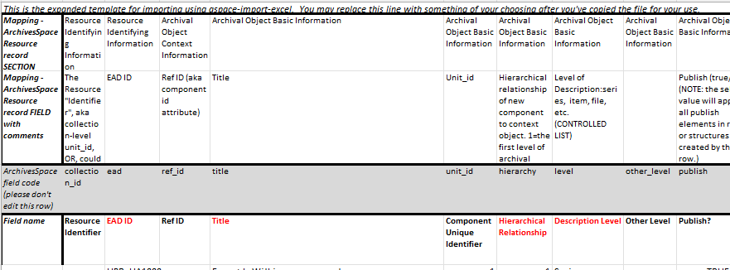
The next three rows are for ArchivesSpace mapping. The first row lists the mapping labels for each field. The second row includes comments about the field that aid the processor in filling out the spreadsheet. The third row has been shaded and is the ArchivesSpace field code that will be linking up each piece of metadata to the system.
The fourth row is another row of field labels to help guide the processor.

Limitations of Import Spreadsheet
Collection-level records must have already been created in ArchivesSpace in order to import child records; though "Collection" appears in the Description Level drop-down, only series-, subseries-, file-, and item-level records can be imported through the spreadsheet. Series and subseries records can be added manually in ArchivesSpace prior to import and then files and items can be imported by series or subseries. Alternatively, the series and subseries records can be included in the import spreadsheet, and all the records (except the collection-level) can be imported at one time.
The template includes every possible importable field available in ArchivesSpace. There are some ArchivesSpace fields that aren't available in the import spreadsheet so these fields will need to be added manually in ArchivesSpace after import (notably the Date Era and Calendar fields are not (yet) available for import). This documentation will call attention to these non-importable fields.
Except for the fields in red, which indicate required fields, columns can be deleted, hidden, or rearranged if they're not needed. For instance, the grandchild indicators are never used at our institution, so the column for Grandchild type and Grandchild indicator can be deleted. This documentation will indicate which fields can be deleted and which can be duplicated.
Note that some columns already have in-column drop down data validation defined.

General Spreadsheet Tips

Data Format Settings
Before you start entering data, set the whole spreadsheet to "Text," not "General." "General" doesn't have any particular format, and as a result Excel tries to guess which format applies based on the data entered, which sometimes results in formatting changes. This is a particular problem for dates. If Excel thinks that a cell is a date, and updates the setting accordingly, it will change the format of the date to Excel's preferred format, which is not DACS compliant and won't import into ArchivesSpace. Further, if you try to change it back after the fact, the date is coded differently, so all of the date must be retyped. "Text" keeps all of the data exactly as you entered it.
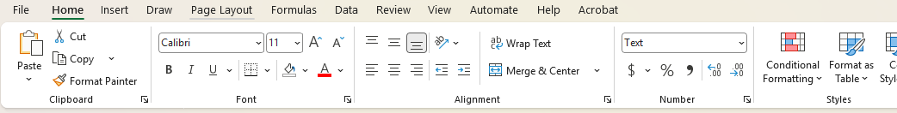
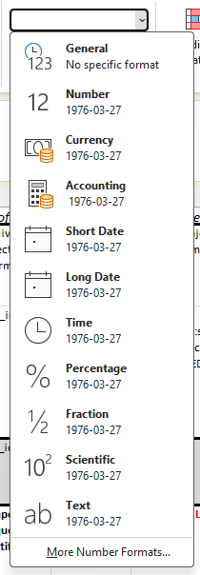

Hiding, Deleting, and Rearranging Columns
The instructions below instruct which fields can be deleted or hidden, but this is only referring to permanently hiding columns. Any column can be temporarily hidden to make the spreadsheet easier to work with, provided that the column is unhidden before import.
Note that columns may also be rearranged as desired to make the worksheet easier to work with—just be sure not to edit the ArchivesSpace field code row, as this (not the order of columns) is what maps spreadsheet columns to fields in Archives Space.

Reducing Row Sizes
Click the "Wrap text" setting on the Home menu to toggle the wrapping setting on or off.
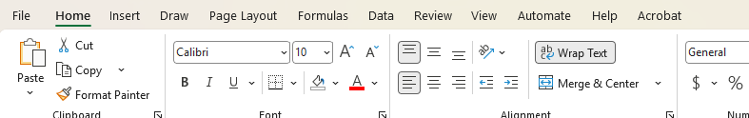
Wrapping the text can help keep columns narrow, so more fields are visible on a screen at once, but it means they can sometimes get to be very tall. Turning off text wrapping will mean not all of the cell text is visible at once, but it will also make cells shorter.
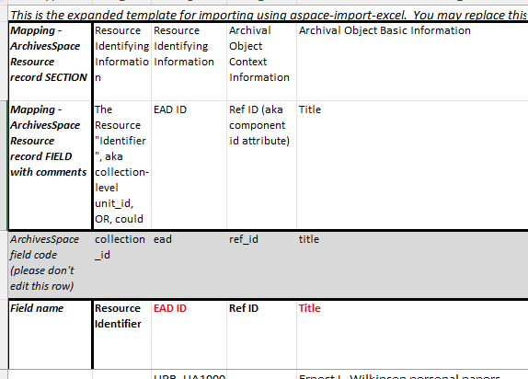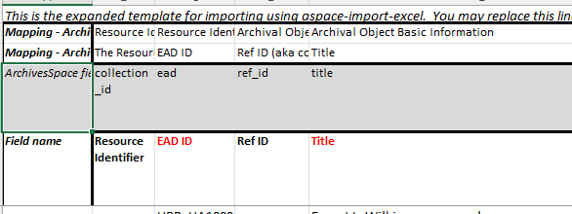
Turning wrapping on or off on some or all header rows (or any rows) may help to make the spreadsheet more useable.

Data Validation
You can also code your own data validation drop-down list for any field in the import spreadsheet, though the instructions below call attention to situations when it may be particularly helpful to do so. If the ArchivesSpace field is a controlled list of values (such as the date label, date certainty, or extent portion), the data validation options must match exactly in order for the spreadsheet to import properly.
Data validation source lists can be created on the Documentation tab in the import spreadsheet; this will not affect the upload. Just be sure not to overwrite any of the existing documentation in the tab.
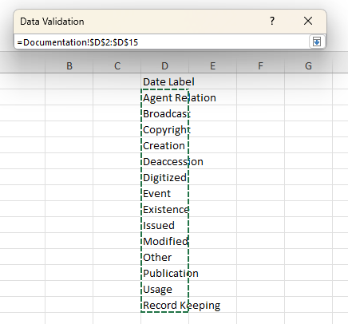
Existing data validation datasets (such as the list for Description Level) can also be edited as needed, though this should be done carefully.
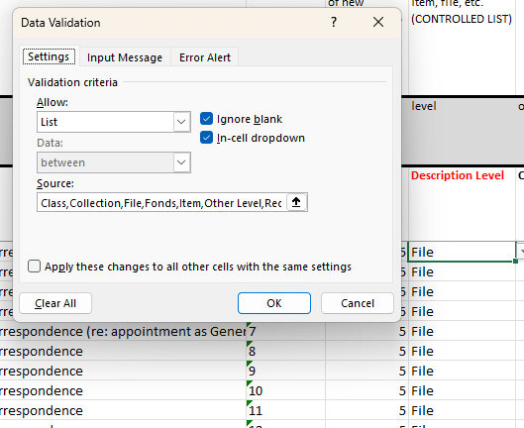

Specific Field Guidelines
The following is a guide on how to fill out each of the fields (each column), with some explanation of metadata standards at our institution, though processing guides should be consulted for further complexity. Each screenshot of the spreadsheet includes the row for the field code, the field label, and an example.

Field Name
This remains blank. It is a label indicating what type of information is contained in the row of field names.
Do not delete, but you may hide this column.
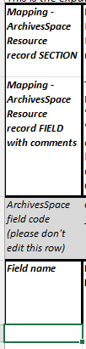

Resource Identifier
This remains blank.
Do not delete, but you may hide this column.
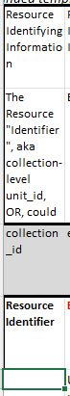

EAD ID
This is stating the information from the EAD ID field in ArchivesSpace, formatted as UPB_[call # with no spaces]. This is a required field and will import your spreadsheet to the correct Resource Record.
The same value will appear on every line on a spreadsheet, so you can drag and fill all of the lines at the beginning or end of processing.
Do not delete, but you may hide this column during processing.
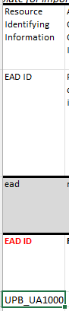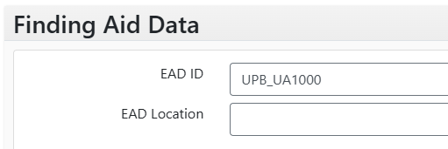

Ref ID
This remains blank.
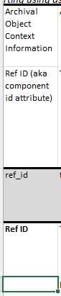

Title
Enter the title of the archival object. Diacritics will import. This is a required field for each record. Refer to the File and Item-level description documentation and/or the Series- and Subseries-level description documentation, as applicable, for guidance on creating titles. Also refer to the Title Style Cheat Sheet for guidance on the format of titles.
Occasionally, the date of the materials can take the place of the title of the materials. In this case, the Title field can be left blank.
Do not delete or hide this column.
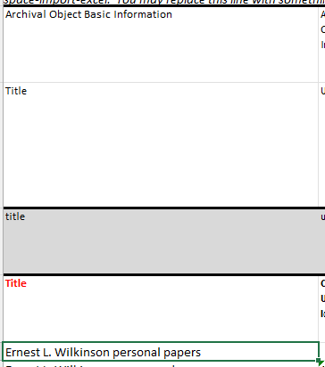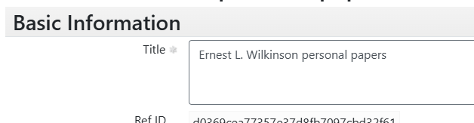

Component Unique Identifier
Enter the component unique ID (series, subseries, file, or item number).
Do not delete or hide this column.
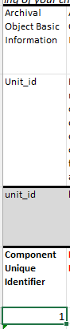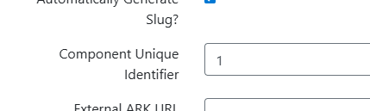

Hierarchical Relationship
This is the relationship of the Archival Object you are entering to the selected resource (If you're entering an inventory below the collection level without series, or if you're entering it at the series or subseries level). If you enter a 1, the spreadsheet will load as a sibling to the series selected at the time of import, or as a child under the collection-level. If you enter a 2, it will load as a child under the series or subseries you selected.
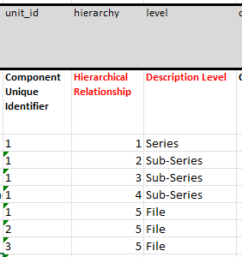
This is a required field. Do not delete or hide this column.
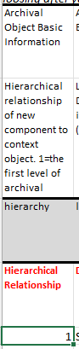

Description Level
This is an in-column drop-down. Choose the relevant description level for the archival object. This is usually "file" and "item", as "series" and "sub-series" are usually entered in manually to ArchivesSpace with less time than it takes to make this spreadsheet, though series- and subseries-level records may be created and imported through the spreadsheet. Collection-level records cannot be created and imported through the spreadsheet, so this should not be selected.
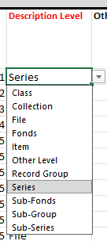
Do not delete or hide this column.
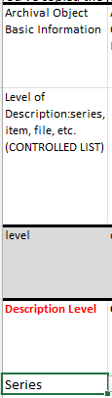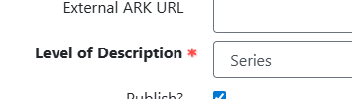

Other Level
Skip the column for other level.
You can delete or hide this column.
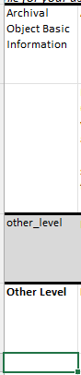

Publish?
If you want the archival object to publish to the public-facing interface, select the drop-down "TRUE." If the record should not be published to the public-facing interface, select the drop-down "FALSE." If you do not select anything, when the spreadsheet imports it will not check the publish box in ArchivesSpace.
This field is not required, but it should be filled out for every line.
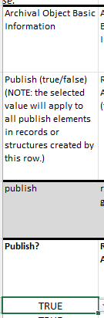

Restrictions Apply?
If the archival object has an access restriction, the "Restrictions Apply?" box should be checked in ArchivesSpace. To check this box, select "TRUE" in the drop-down on the spreadsheet. If there are no access restrictions, select "FALSE." If you do not select anything, when the spreadsheet imports it will not check the restrictions box. This field is not required, but it should be filled out for every line.
Please note that access restrictions should be reflected in a Conditions Governing Access note, though this note may be at the level of the archival object or it may be applied at a higher level and inherited. Refer to the File and Item-level description documentation and/or the Series- and Subseries-level description documentation, as applicable, for further guidance on access restrictions.
Do not delete or hide this column.
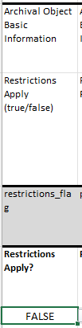

Processing Note
Skip the column for other Repository Processing Note (and delete or hide it to make the spreadsheet more useable).
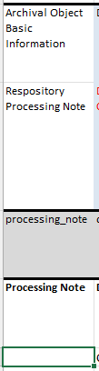

Dates
The dates section is color coded to group all of the fields together, and all are identified by the label "Dates" in the ArchivesSpace Resource record Section row.
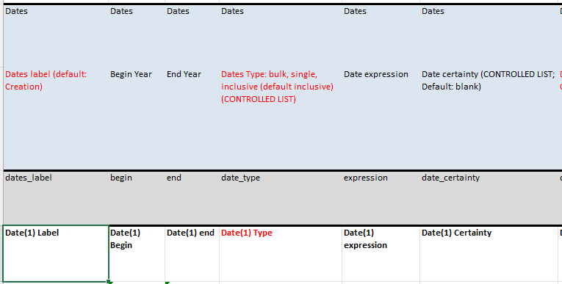
Note that the Date era field and Date calendar field don't appear on the import spreadsheet. For every date statement that is added through the import spreadsheet, the era and calendar will need to be added manually in ArchivesSpace after import.
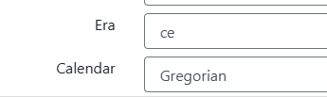

Dates Label
Type the date label you will be using, matching the format of the selections in the ArchivesSpace drop-down controlled value list. Most often, this is "Creation." The spreadsheet won't import data from the date fields if this label field is not filled out or does not match the controlled value list.
You can also code your own data validation drop-down list using some or all of the values from ArchivesSpace.
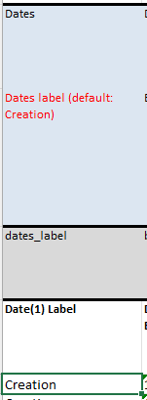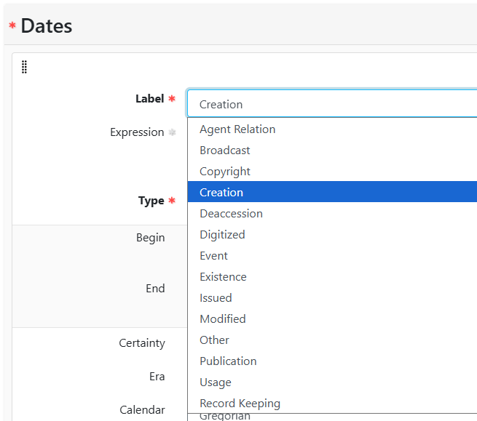

Date Begin and Date End
Date Begin and Date End fields should have dates entered in standardized form as entered into the field in ArchivesSpace (where there is an option to select from a calendar).
- YYYY, YYYY-MM, or YYYY-MM-DD
- i.e., 1979-09-01 for September 1, 1979
If there is a range of dates, fill out both the Date Begin and Date End fields. If it is a single date, leave the Date End field blank.
As mentioned above, be sure to set these fields to "Text" before you start making edits, or Excel will auto-detect that the entries in these columns are dates and change the values to Excel's own format, which won't import properly into ArchivesSpace.
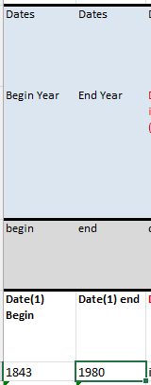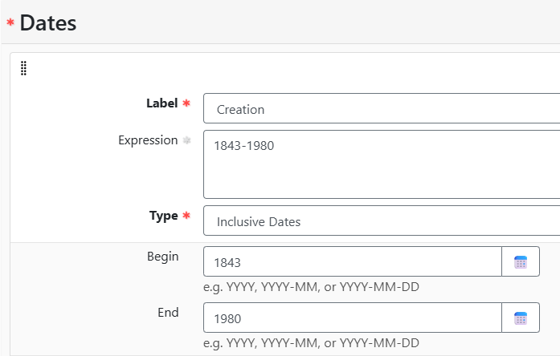

Date Type
Select "bulk," "single," or "inclusive" from the drop-down selection. Bulk is rarely used, and never as the sole date statement. Inclusive is used for a date range, and single is used for a single date. If you select single, any value in the Date End column will be ignored. If you type in something besides the three options, it will be overriden with the value "inclusive."
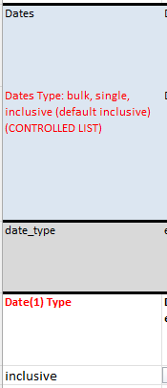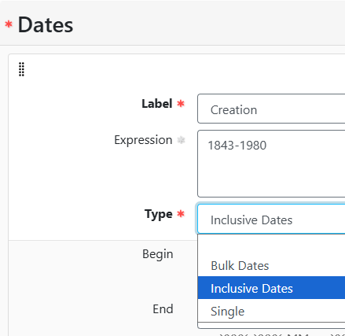

Date Expression
This is the full DACS date (e.g., 1979 September 1). Or, if it's been approximated, "approximately 1979," "before 1979," or "after 1979," or "1979 Summer," and other expressions outlined in the Procedure Manual.
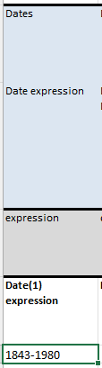

Date Certainty
If the date was approximated or inferred, put "approximate" (NOT "approximately") or "inferred" here. If it was known, leave this cell blank.
You can also code your own data validation drop-down list using some or all of the values from ArchivesSpace.
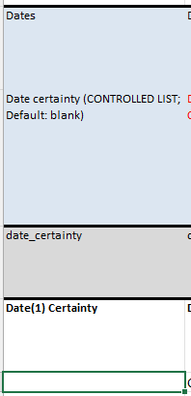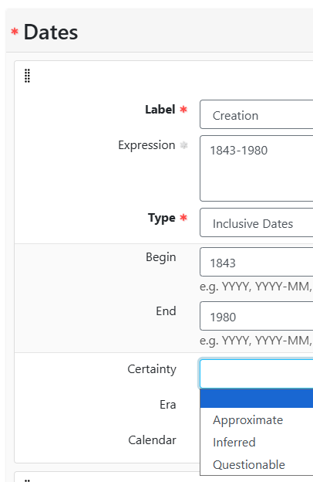

Additional Dates Statements
Add additional date statements by copying all of the Date fields (Date Label, Date Begin, Date End, Date Type, Date Expression, Date Certainty) and inserting them as new columns.
Update the values in the ArchivesSpace field code row as follows:
- Add "_[number]" to the end of each field.
- So, the field that was "dates_label" for the first Date statement becomes "dates_label_2" for the second Date statement and "dates_label_3" for the third Date statement. Repeat for the date beginning and ending, date type, date expression, and date certainty columns.
Update the values in the Field name row as follows:
- Update the "([number])" after "Date" in each field.
- So, the field that was "Date (1) Label" for the first Date statement becomes "Date (2) Label" for the second Date statement and "Date (3) Label" for the third Date statement. Repeat for the date beginning and ending, date type, date expression, and date certainty columns.
Be sure to copy all of the date statement fields and update the labels for both rows in each column.
Note that the Date era field and Date calendar field don't appear on the import spreadsheet. For every date statement that is added through the import spreadsheet, the era and calendar will need to be added manually in ArchivesSpace after import.
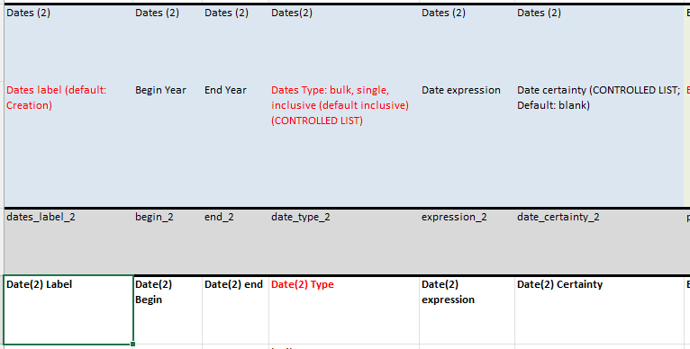

Extents
The extent section is color coded to group all of the fields together, and all are identified by the label "Extent information" in the ArchivesSpace Resource record Section row.
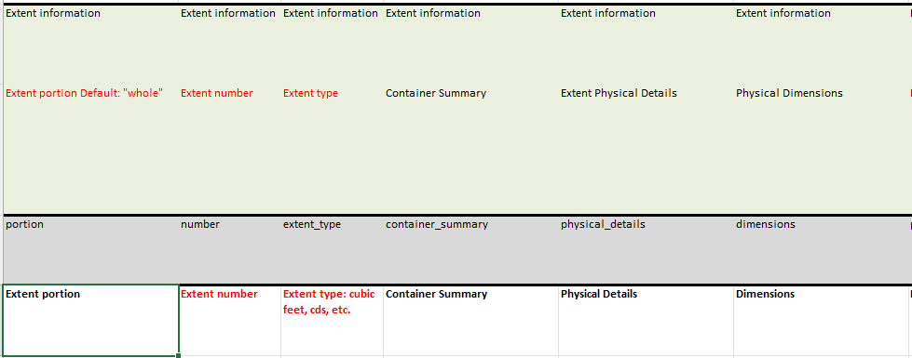

Extent Portion
Type the extent portion ("whole" if there is only one extent, "part" if there are multiple parts to the extent).
You can also code your own data validation drop-down list using the values from ArchivesSpace.
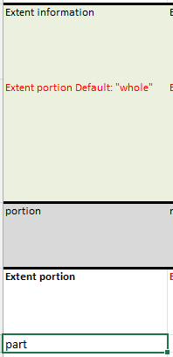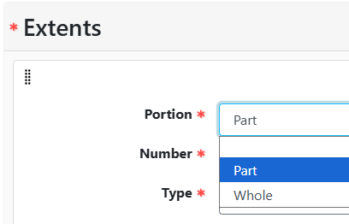

Extent Number
If you are adding an extent, this field is required. Type the number reflecting the number of containers or type of materials in your extent.
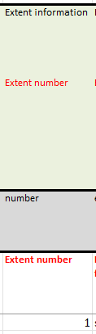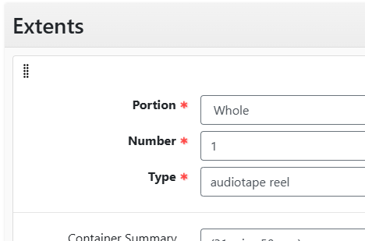

Extent Type
If you are adding an extent, this field is also required. Your entry must match the controlled value list in ArchivesSpace. A full list of these terms is available in the Extent terms spreadsheet, which also includes guidance on which extent term corresponds with specific material types.
You can also code your own data validation drop-down list using the values from ArchivesSpace (which can be easily retrieved from the Extent terms spreadsheet).
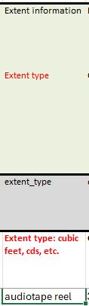

Container Summary
Enter the container summary information, if applicable. This field can remain blank. File level description for folders does not have a Container Summary. Refer to Refer to the File and Item-level description documentation for guidance on what information belongs in the Container Summary field.
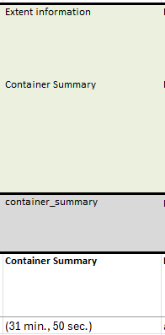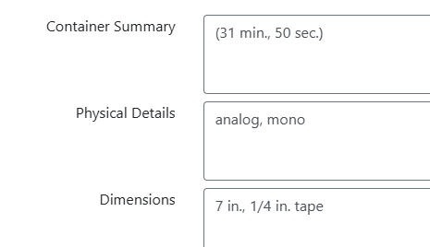

Physical Details
Enter the physical details for the extent if applicable, otherwise leave blank. This field is more commonly used with item-level description. Refer to Refer to the File and Item-level description documentation for guidance on what information belongs in the Physical Details field.
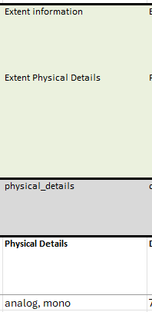

Dimensions
Enter the dimensions for the extent if applicable, otherwise leave blank. This field is more commonly used with item-level description. Refer to the File and Item-level description documentation for guidance on when and how to record dimensions.
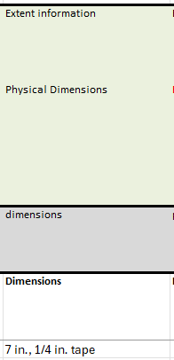

Additional Extent Statements
Add additional extent statements by copying all of the Extent fields (Extent portion, Extent number, Extent type, Container Summary, Physical Details, Dimensions) and inserting them as new columns.
Update the values in the ArchivesSpace field code row as follows:
- Add "_[number]" to the end of each field.
- So, the field that was "portion" for the first Extent statement becomes "portion_2" for the second Extent statement and "portion_3" for the third Extent statement. Repeat for the extent number, extent type, container summary, physical details, and dimensions columns.
Update the values in the Field name row as follows:
- Add "([number])" at the end of each field (and before the colon in the extent type field).
- So, the field that was "Extent portion" for the first Extent statement becomes "Extent portion(2)" for the second Extent statement and "Extent portion(3)" for the third Extent statement. Repeat for the extent number, extent type, container summary, physical details, and dimensions columns.
Be sure to copy all of the extent statement fields and update the labels for both rows in each column.
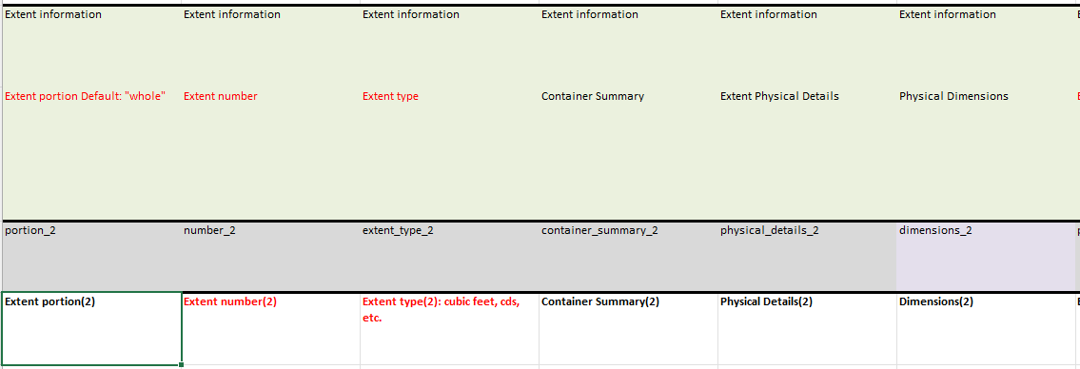

Instances
The instances section is color coded to group all of the fields together, and all are identified by the label "Container information" in the ArchivesSpace Resource record Section row.
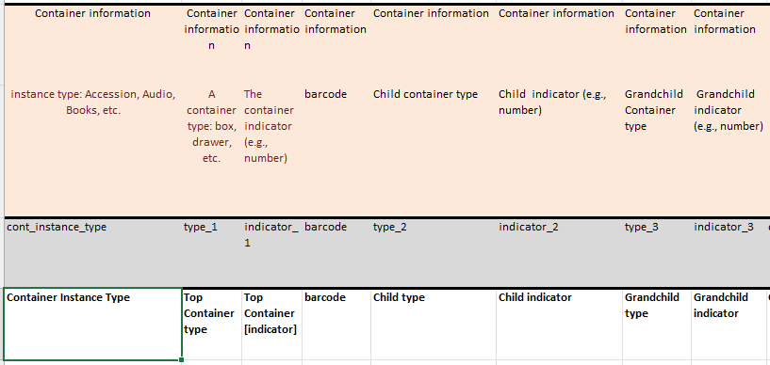

Container Instance Type
Container Instance Type is a controlled value list in ArchivesSpace and the selection should be typed in exactly as it matches in that list, including capitalization. If you are adding container information, the Type and Indicator must both be present, otherwise the indicator value will import as "unknown."
You can also code your own data validation drop-down list using the values from ArchivesSpace.
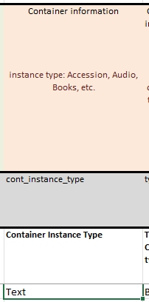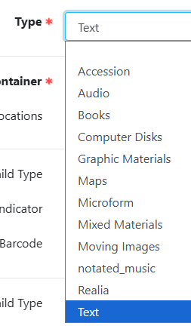

Top Container Type
Top Container Type is a controlled value list in ArchivesSpace and the selection should be typed in exactly as it matches in that list, including capitalization.
You can also code your own data validation drop-down list using some or all of the values from ArchivesSpace.
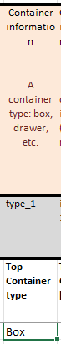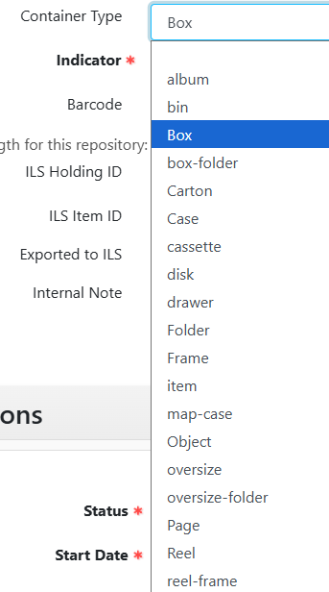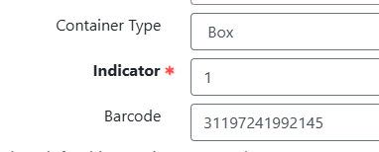

Top Container [Indicator]
Type the container number into this field.
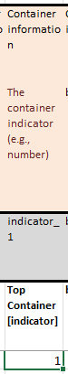

Barcode
Enter the barcode for the container the archival object belongs to, if available. If you have a barcode, the system will search for that matching number and assign the Top Container already attached to it. If there is no match, or no barcode number is provided, a new Top Container will be created based on the information you provided above. If the container has not yet been assigned a barcode by Collection Management, leave this field blank.
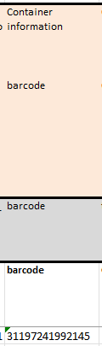

Child Type
Child Type is a controlled value container type list in ArchivesSpace and the selection should be typed in exactly as it matches in that list. If you are adding container information, the Child Type and Child Indicator must both be present, otherwise the indicator value will import as "unknown."
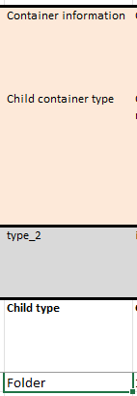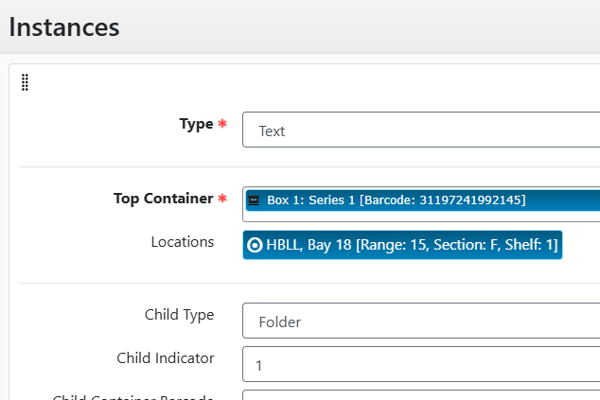

Child Indicator
Type the child container number into this field. If nothing is put here and the Child type field is filled out, the field will import as "unknown."
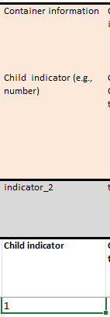

Grandchild Type and Grandchild Indicator
Grandchild type and indicator should be deleted or hidden from the spreadsheet. We don't use this field at the BYU Library.
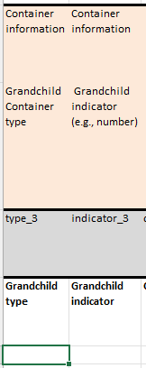

Additional Instance Statements
Add additional instance statements by copying all of the Instance fields (Container Instance type, Top container type, Top container [indicator], barcode, Child type, Child indicator) and inserting them as new columns (you can copy the Grandchild fields or not, since they may be deleted anyway).
Update the values in the ArchivesSpace field code row as follows:
- Add "_[number]" to the end of each field.
- So, the field that was "cont_instance_type" for the first Instance statement becomes "cont_instance_type_2" for the second Instance statement and "cont_instance_type_3" for the third Instance statement. Repeat for the top container type, top container indicator, barcode, child type, and child indicator columns.
Update the values in the Field name row as follows:
- Add "([number])" at the end of each field.
- So, the field that was "Container Instance Type" for the first Instance statement becomes "Container Instance Type(2)" for the second Instance statement and "Container Instance Type(3)" for the third Instance statement. Repeat for the top container type, top container indicator, barcode, child type, and child indicator columns.
Be sure to copy all of the instance statement fields (except the grandchild type and indicator fields) and update the labels for both rows in each column.
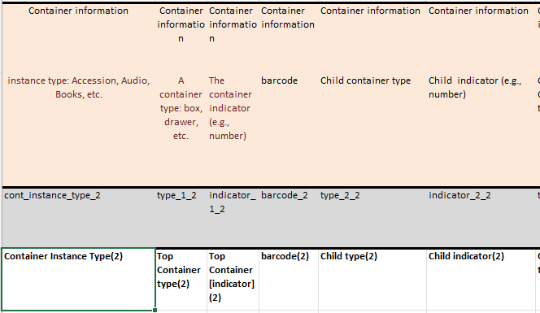

Digital Object fields
Digital Object Title, URL of Linked-out digital object, and URL of thumbnail are fields are not used by the Archival Processing Section.
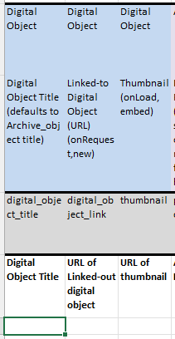

Agents
The Agents section is color coded to group all of the fields together (the Subjects section is grouped in the same color), and all are identified by the label "Agent Links" in the ArchivesSpace Resource record Section row.
There are three types of agent links, and each have their own sets of columns: People Agents, Family Agents, and Corporate Agents.
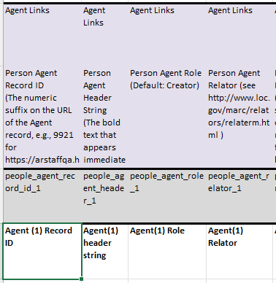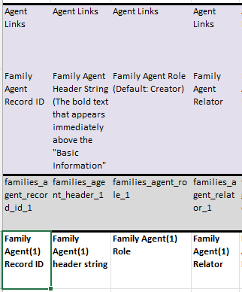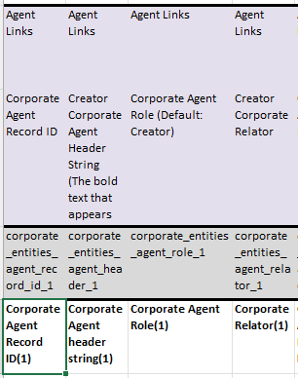
Note that the import spreadsheet doesn't have the capability to import terms and subdivisions for subject-agents. If an agent is listed as a subject and you'd like to add a subdivision to the term, this will need to be done manually on ArchivesSpace after import.
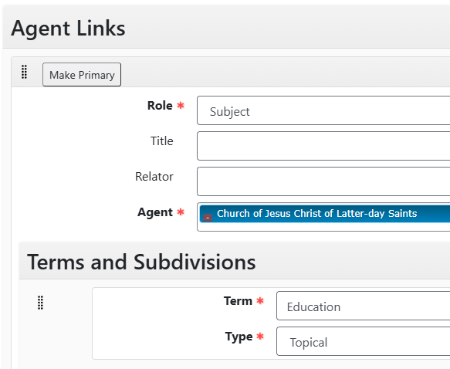

People Agents
People agent links are records for individual people.

Agent Record ID
If you have a Person Agent record you would like to link to the archival object, you must use the Record ID number that shows up at the end of the URL when the Agent record is open in ArchivesSpace. You must use this or the full header string to match the records. If no Agent record is found to match, ArchivesSpace will create a new Agent record on import.
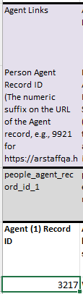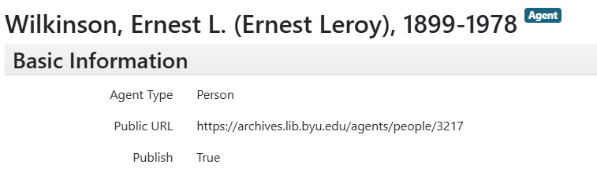

Agent Header String
If you have a Person Agent record you would like to link to the archival object, you must use the header string exactly as it appears in ArchivesSpace, with all capitalization and punctuation. You must use this or the Record ID to match the records. If no Agent record is found to match, ArchivesSpace will create a new Agent record on import.
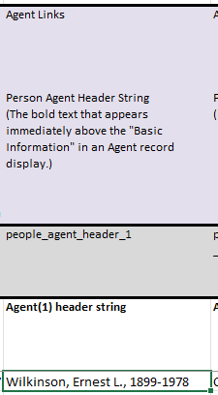

Agent Role
Type the Role label for this agent, matching the format of the selections in the ArchivesSpace drop-down controlled value list.
You can also code your own data validation drop-down list using some or all of the values from ArchivesSpace.
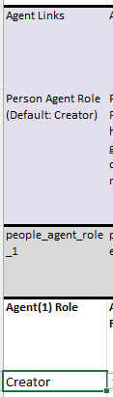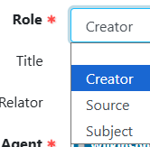

Agent Relator
If you choose to supply a relator for the Person Agent (not required), it must come from the Agent Archival Record Relators controlled value list in ArchivesSpace:
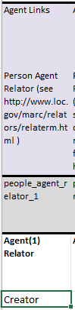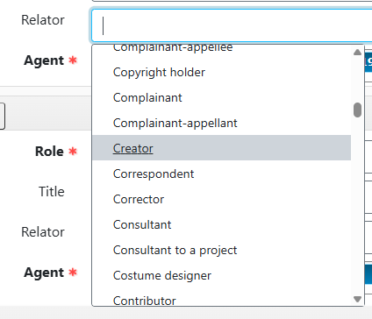

Additional People Agent Links
The second and third sets of columns for People agents can be used, deleted, or hidden. If more than three Person agents are needed, additional sets of columns can be created by copying all of the Agent record fields (Agent Record ID, Agent header string, Agent Role, and Agent Relator) and inserting them as new columns.
Update the values in the ArchivesSpace field code row as follows:
- Update the number at the end of each field.
- So, the field that was "people_agent_record_id_1" for the first Agent link becomes "people_agent_record_id_3" for the third Agent link and "people_agent_record_id_4" for the fourth Agent link. Repeat for the agent header string, agent role, and agent relator columns.
Update the values in the Field name row as follows:
- Update the "([number])" after "Agent" in each field.
- So, the field that was "Agent (1) Record ID" for the first Agent link becomes "Agent (3) Record ID" for the third Agent link and "Agent (4) Record ID" for the fourth Agent link. Repeat for the agent header string, agent role, and agent relator columns.
Be sure to copy all of the agent link fields and update the labels for both rows in each column.
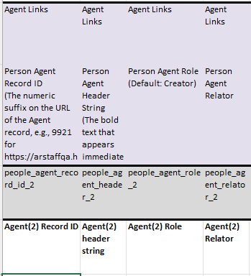

Family Agents
Family agent links are records for families.

Family Agent Record ID
If you have a Family Agent record you would like to link to the archival object, you must use the Record ID number that shows up at the end of the URL when the Agent record is open in ArchivesSpace. You must use this or the full header string to match the records. If no Agent record is found to match, ArchivesSpace will create a new Agent record on import.
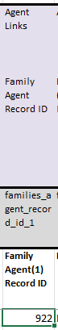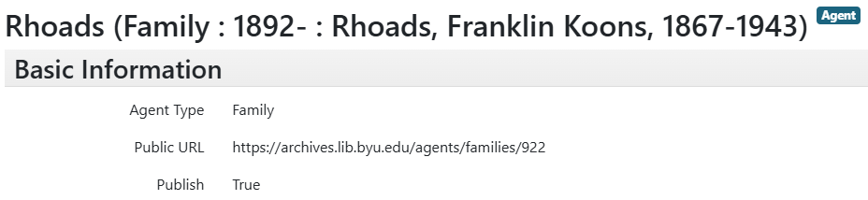

Family Agent Header String
If you have a Family Agent record you would like to link to the archival object, you must use the header string exactly as it appears in ArchivesSpace, with all capitalization and punctuation. You must use this or the Record ID to match the records. If no Agent record is found to match, ArchivesSpace will create a new Agent record on import.
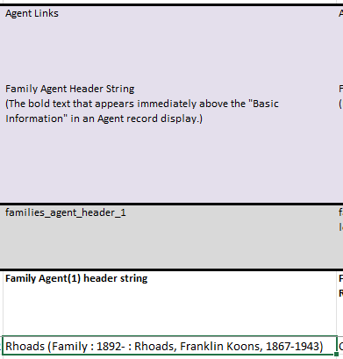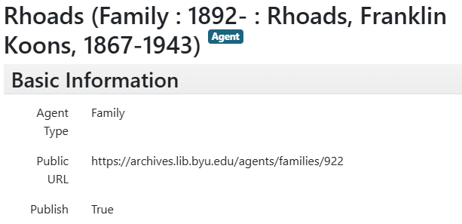

Family Agent Role
Type the Role label for this agent, matching the format of the selections in the ArchivesSpace drop-down controlled value list.
You can also code your own data validation drop-down list using some or all of the values from ArchivesSpace.
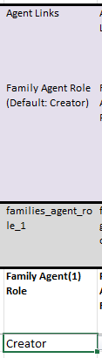

Family Agent Relator
If you choose to supply a relator for the Person Agent (not required), it must come from the Agent Archival Record Relators controlled value list in ArchivesSpace:
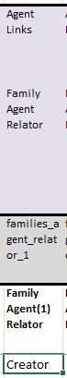

Additional Family Agent Links
The second and third sets of columns for Family agents can be used, deleted, or hidden. If more than three Family agents are needed, additional sets of columns can be created by copying all of the Agent record fields (Family Agent Record ID, Family Agent header string, Family Agent Role, and Family Agent Relator) and inserting them as new columns.
Update the values in the ArchivesSpace field code row as follows:
- Update the "_[number]" at the end of each field.
- So, the field that was "families_agent_record_id_1" for the first Agent link becomes "families_agent_record_id_3" for the third Family Agent link and "families_agent_record_id_4" for the fourth Family Agent link. Repeat for the family agent header string, family agent role, and family agent relator columns.
Update the values in the Field name row as follows:
- Update the "([number])" after "Agent" in each field.
- So, the field that was "Family Agent (1) Record ID" for the first Agent link becomes "Family Agent (3) Record ID" for the third Family Agent link and "Family Agent (4) Record ID" for the fourth Family Agent link. Repeat for the family agent header string, family agent role, and family agent relator columns.
Be sure to copy all of the agent link fields and update the labels for both rows in each column.
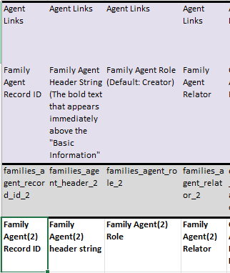

Corporate Agents
Corporate agent links are records for businesses, corporate bodies, and organizations.

Corporate Agent Record ID
If you have a Corporate Agent record you would like to link to the archival object, you must use the Record ID number that shows up at the end of the URL when the Agent record is open in ArchivesSpace. You must use this or the full header string to match the records. If no Agent record is found to match, ArchivesSpace will create a new Agent record on import.
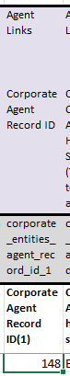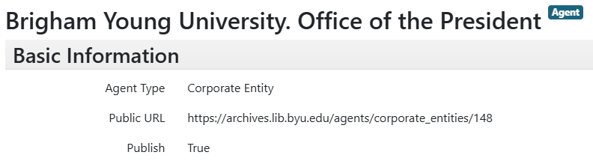

Corporate Agent Header String
If you have a Corporate Agent record you would like to link to the archival object, you must use the header string exactly as it appears in ArchivesSpace, with all capitalization and punctuation. You must use this or the Record ID to match the records. If no Agent record is found to match, ArchivesSpace will create a new Agent record on import.
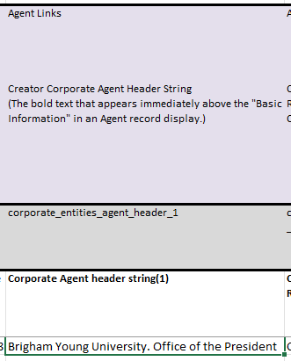

Corporate Agent Role
Type the Role label for this agent, matching the format of the selections in the ArchivesSpace drop-down controlled value list.
You can also code your own data validation drop-down list using some or all of the values from ArchivesSpace.
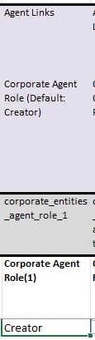

Corporate Agent Relator
If you choose to supply a relator for the Corporate Agent (not required), it must come from the Agent Archival Record Relators controlled value list in ArchivesSpace:
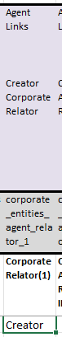

Additional Corporate Agent Links
The second and third sets of columns for Corporate agents can be used, deleted, or hidden. If more than three Corporate agents are needed, additional sets of columns can be created by copying all of the Agent record fields (Corporate Agent Record ID, Corporate Agent header string, Corporate Agent Role, and Corporate Relator) and inserting them as new columns.
Update the values in the ArchivesSpace field code row as follows:
- Update the "_[number]" at the end of each field.
- So, the field that was "corporate_entities_agent_record_id_1" for the first Agent link becomes "corporate_entities_agent_record_id_3" for the third Corporate Agent link and "corporate_entities_agent_record_id_4" for the fourth Corporate Agent link. Repeat for the corporate agent header string, corporate agent role, and corporate relator columns.
Update the values in the Field name row as follows:
- Update the "([number])" at the end of each field.
- So, the field that was "Corporate Agent Record ID (1)" for the first Agent link becomes "Corporate Agent Record ID (3)" for the third Corporate Agent link and "Corporate Agent Record ID (4)" for the fourth Corporate Agent link. Repeat for the corporate agent header string, corporate agent role, and corporate relator columns.
Be sure to copy all of the agent link fields and update the labels for both rows in each column.
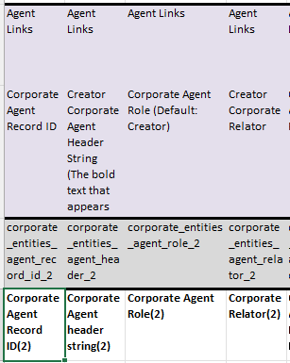

Subjects
The Subjects section is color coded to group all of the fields together (the Agents section is grouped in the same color), and all are identified by the label "Subjects" in the ArchivesSpace Resource record Section row.
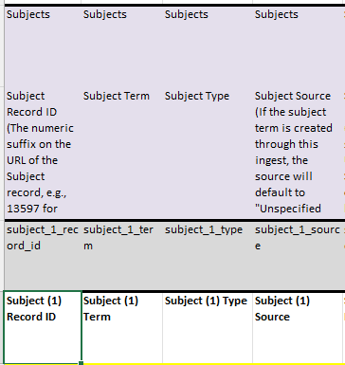

Subject Record ID
Subjects can be added to each archival object in the spreadsheet, and we do want all file and item level archival objects to be associated with a genre/form subject heading. You must use the Record ID number that shows up at the end of the URL when the subject record is open in ArchivesSpace. You must use this or the full header string, type, and source together to match the records. If no subject record is found to match, ArchivesSpace will create a new subject record on import.
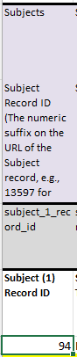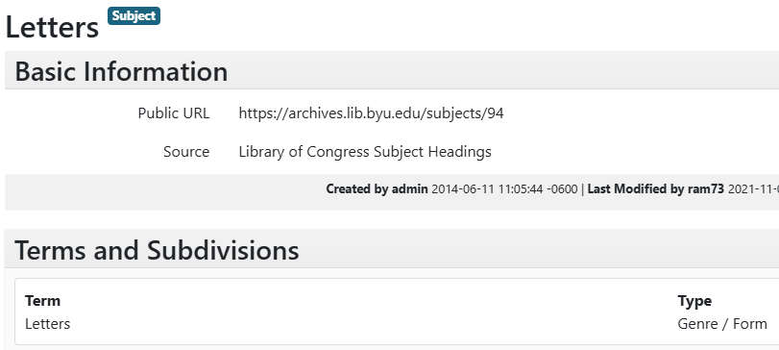

Subject Term
If you have a subject record you would like to link to the archival object, you must use the header string exactly as it appears in ArchivesSpace, with all capitalization and punctuation. You must use this along with the type and source, or just the Record ID, to match the records. If no subject record is found to match, ArchivesSpace will create a new Agent record on import.
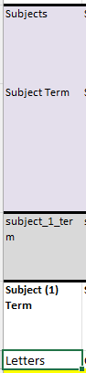

Subject Type
Subject Type is a controlled value list in ArchivesSpace and the selection should be typed in exactly as it matches in that list and has been assigned to the subject record. The header string, type, and source must all be present together to match a record in ArchivesSpace, or the Record ID by itself can also be used to match a record. If no subject record is found to match, ArchivesSpace will create a new Agent record on import. When creating that record, if no type is selected, "topical" will be the default.
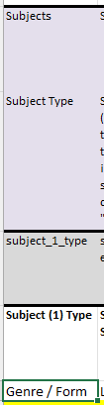

Subject Source
Subject Source is a controlled value list in ArchivesSpace and the selection should be typed in exactly as it matches in that list and has been assigned to the subject record. The header string, type, and source must all be present together to match a record in ArchivesSpace, or the Record ID by itself can also be used to match a record. If no subject record is found to match, ArchivesSpace will create a new Agent record on import. When creating that record, if no source is selected, "ingest" will be the default.
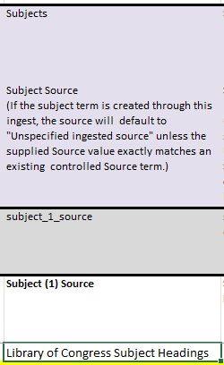

Additional Subject Links
The second set of columns for Subjects can be used or deleted.
The second set of columns for Subjects can be used, deleted, or hidden. If more than Subject links are needed, additional sets of columns can be created by copying all of the Subject record fields (Subject Record ID, Subject term, Subject Type, and Subject Source) and inserting them as new columns.
Update the values in the ArchivesSpace field code row as follows:
- Update the "_[number]" after "subject" in each field.
- So, the field that was "subject_1_record_id" for the first Subject link becomes "subject_3_record_id" for the third Subject link and "subject_4_record_id" for the fourth Subject link. Repeat for the subject term, subject type, and subject source columns.
Update the values in the Field name row as follows:
- Update the "([number])" at the end of each field.
- So, the field that was "Subject (1) Record ID" for the first Subject link becomes "Subject (3) Record ID" for the third Subject link and "Subject (4) Record ID" for the fourth Subject link. Repeat for the subject term, subject type, and subject source columns.
Be sure to copy all of the agent link fields and update the labels for both rows in each column.
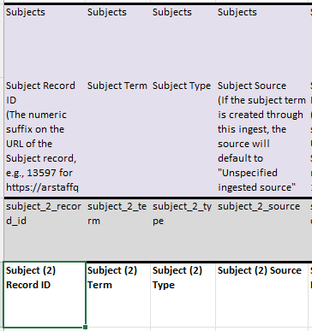

Using ASpace genreform terms Spreadsheet
The spreadsheet ASpace genreform terms.xlsx is saved in catshare\Archival Processing Section\Spreadsheet training. This spreadsheet can be used to simply search and/or browse for the proper genre/form term to use for an item or group of materials, but it can also be used to make it easier to fill out the four columns for subjects on the import spreadsheet.

Spreadsheet Setup
Always work on assigning genre/form terms in a separate spreadsheet—not in the import spreadsheet. This can be a completely separate document or just a separate tab in the import spreadsheet. If you create new tabs in the import spreadsheet, you'll just have to remember to delete these tabs before uploading the spreadsheet to ArchivesSpace. The following screenshots will show these tabs created on the import spreadsheet, but the process is the same for either method.
The import spreadsheet comes pre-loaded with two tabs: "Data" is the tab where metadata is added for import and "Documentation" has notes about how the spreadsheet functions. Add two tabs—they can have any title, and the order of the tabs doesn't matter, but one will be where genre/form terms are assigned (called "genreform" here) and the other will have the reference data and coding (called "data reference" here).
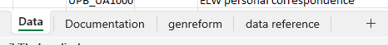
In the Genreform tab, copy and paste and necessary identifying information from the import spreadsheet—this may include file and item titles, component unique IDs, levels of description, instances, and/or any other information. Also add the four columns for subjects and then duplicate as needed for the inclusion of additional subject links. It may be easiest to do the following coding in one set of columns, and only then duplicate the columns to create additional spaces for subject links (as opposed to doing the coding in each column individually).
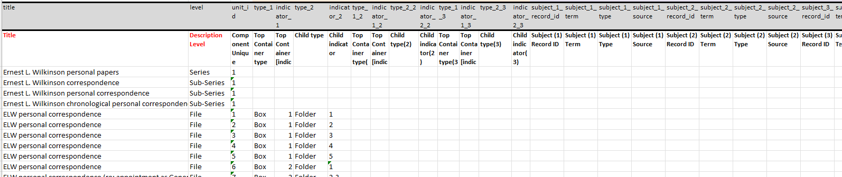
In the Data reference tab, copy and paste columns A-E from ASpace genreform terms.xlsx.
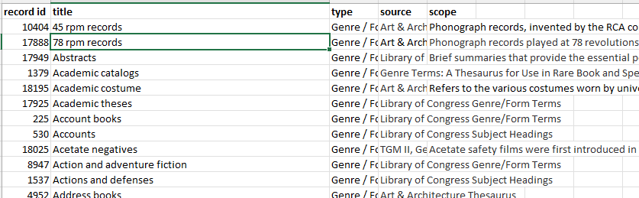

Set up Genre/Form Data Validation
Return to the Genreform tab. Highlight all of the cells in the Subject Term column (except the header rows).
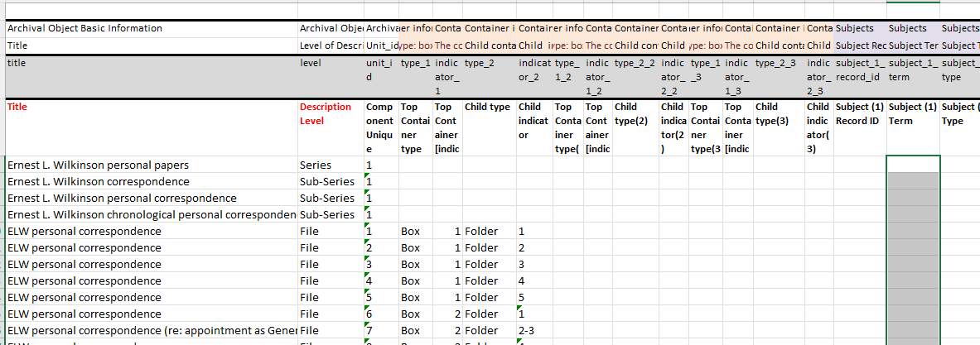
Click the "Data" menu, then click the "Data Validation" arrow, then click "Data Validation."
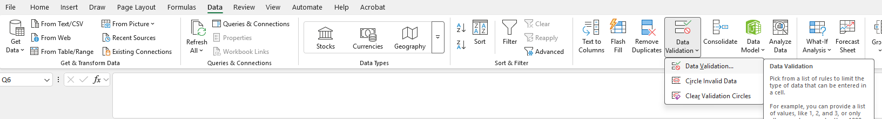
This will bring up the Data Validation menu. For "Allow" select "List." For "Source" click the arrow button to allow you to highlight the subject terms column on the Data reference tab. Be sure not to highlight the header for this column, or else someone may inadvertently assign "title" as a genre/form term. The source will look something like: ='[tab name]'![top cell address]:[bottom cell address]. Click the blue arrow button to return to the Data Validation menu and click "OK."
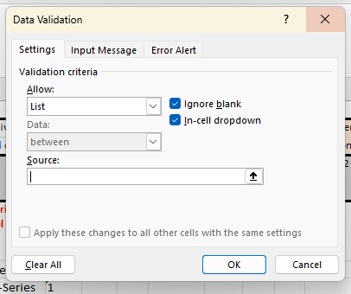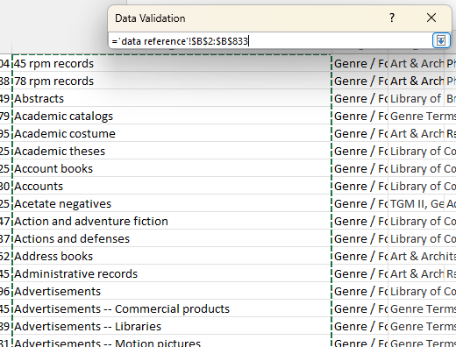
Copy this data validation formatting to the other Subject Term columns as needed.

Assigning Genre/Form Terms
When you return to the Genreform tab, there is now the option to click the arrow next to the cell and select a term from the dropdown menu.
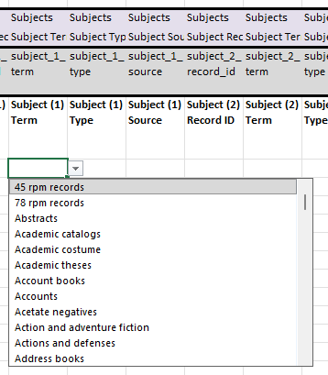
Alternatively, you can start typing in a cell to search through the options in the dropdown menu, then select the correct term.
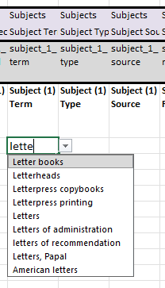
If you accidentally add an unnecessary subject link (for instance, you add a third link but there are only two material types in the file), hit the "delete" key (not the backspace key) while you have the error selected. This will return the cell to a blank.
Genre/form terms can be added before or after the Record ID, Type, and Source columns are coded.

Coding the Record ID, Type, and Source Columns
We're going to code an XLOOKUP function in the Record ID, Type, and Source columns. The XLOOKUP function refers to a cell (in this case, the Subject Term cell), looks for the value in that cell in an array (in this case, the array is the "title" column in the Data reference tab), and then returns a corresponding value from another array (in this case, the record id, type, or source columns in the Data reference tab).
Use "$" in formulas to change a cell reference from relative to absolute. This is most relevant, in this context, to making sure that the right parts of a formula will update from cell to cell. For example, if a formula in H1 (column H row 1) refers to cell F1 and the formula is dragged down to H2, the cell reference will update to F2. If the formula is dragged right from H1 to I1, the cell reference will update to G1. Adding "$" before the column reference ($F1) will lock the column reference but not the row reference, so dragging the formula from H1 to H2 will have the cell reference update from F1 to F2, but dragging the formula from H1 to I1 will have the cell reference remain F1. Adding "$" before the row reference (F$1) will lock the row reference but not the column reference, so dragging the formula from H1 to H2 will have the cell reference remain F1 but dragging the formula from H1 to I1 will result in the cell reference updating from F1 to G1. Adding "$" before both the column and row reference ($F$1) will result in the cell reference not updating, regardless of where the formula is copied or dragged to fill.
The format of the XLOOKUP function is:
- =XLOOKUP([lookup_value],[lookup_array],[return_array],[if_not_found],[match mode])
The if_not_found and match_mode elements are optional, but they may help your formula to work better.
To code the Subject Record ID column, go to the Genreform tab and select the first row in the Subject Record ID column. Follow these steps:
- Type "=XLOOKUP(" (without the quotation marks)
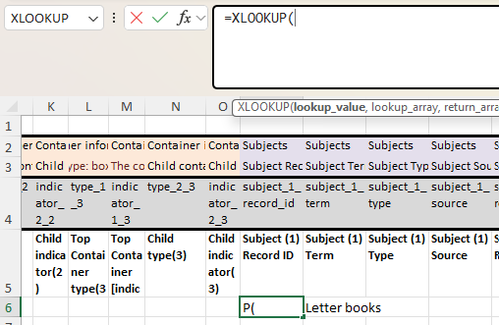
- Lookup_value is the value the formula should search for. Select (or type the cell address for) the cell on the same row in the Subject Term column, then follow the reference by a comma. Add "$" as needed to lock cell references—here you can see I've locked the reference to column Q, so it will always refer to the Subject term column, but I haven't locked the row reference, so line 7 will refer to line 7, line 8 to line 8, etc.
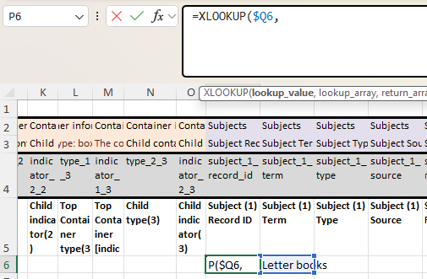
- Lookup_array is where the program should search for the subject term. Select the "title" column in the Data reference tab, then follow the reference by a comma. (To select a whole column, write "[column identifier]:[column identifier]." For example, to select all of column L, write L:L.)
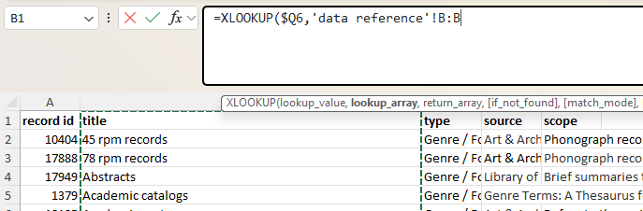
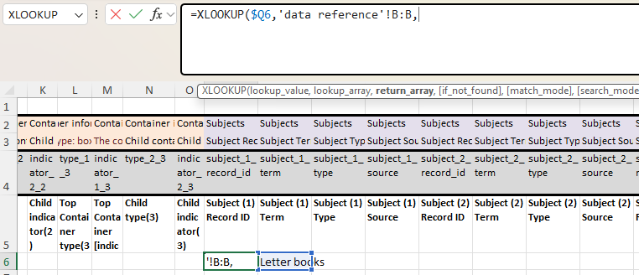
Note the inclusion of the tab reference in the cell reference—the tab name is enclosed in single quotation marks and then separated from the cell address by an exclamation point.
- Return_array is where the formula should retrieve the value that matches the subject term. Select the "record id" column in the Data reference tab, then follow the reference by a comma.
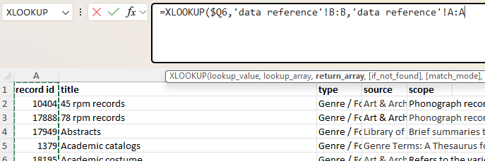
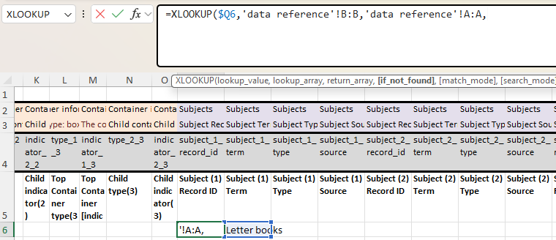
- If_not_found is the value for the formula to return if it can't find an exact match between the term entered on the Genreform tab and the list on the Data reference tab. Because we're using data validation to refer to the same values, this should be impossible, but it's good to be extra sure, especially since your subject terms need to match what's in ArchivesSpace exactly in order to import. Enter the text you want the formula to display—in quotation marks—if your terms don't match. For instance, if you want the formula to say "ERROR" if it can't find a matching term, then write "ERROR." If you forget the quotation marks, the formula will throw an error. Follow this with a comma.
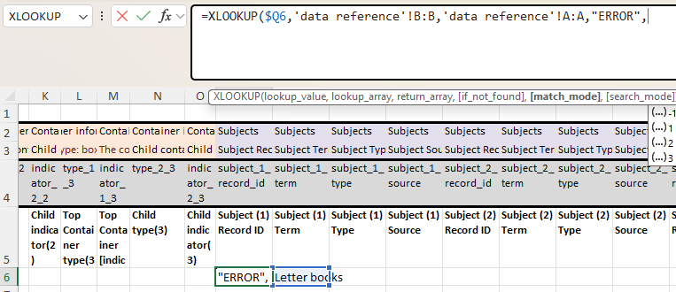
- Match_mode specifies whether the formula should return only exact matches or if close matches are okay. Since we're only concerned with exact matches and we want to be alerted if something isn't an exact match, enter 0 (not quotation marks needed), then close the formula with a parenthesis.
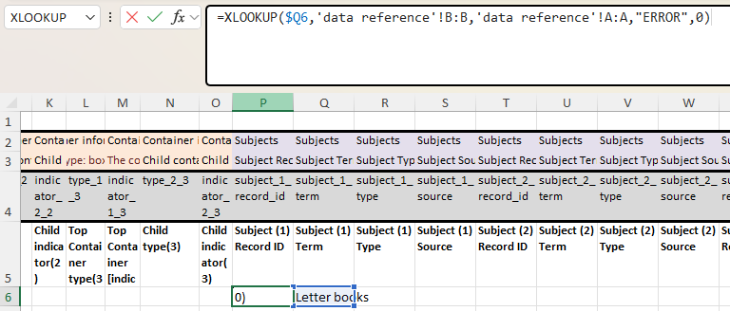
- Hit "enter" and value in the Subject Record ID column will update to the record ID that matches the term in the Subject Term column.
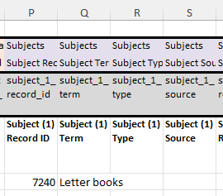
- Select the cell where you composed the formula (the first non-header row in the Subject Record ID column) and hold down the ctrl key and the shift key then hit the down arrow. This will highlight the rest of the column.
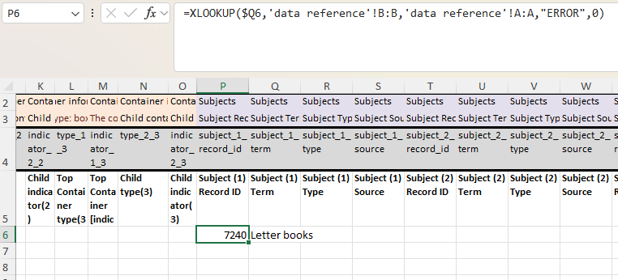
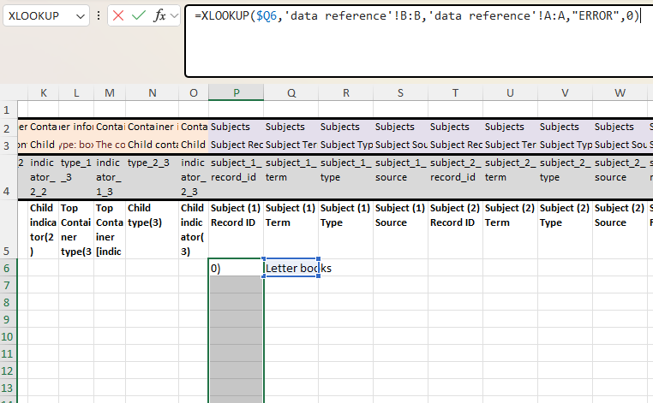
- While these cells are highlighted, hold down the ctrl key then hit d. This will fill the formula to the rest of the column. (For cells where the Subject term isn't yet filled out, the formula will display either "0" or the if_not_found value.) As you enter new Subject terms, the formula in the Subject Record ID column will automatically update.
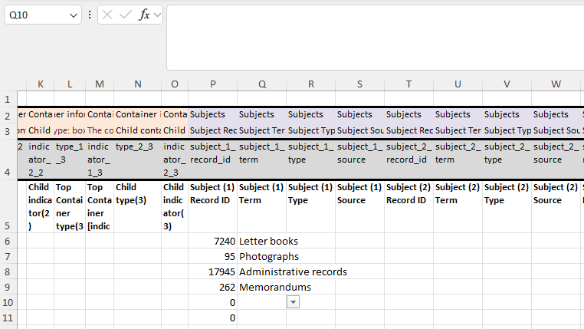
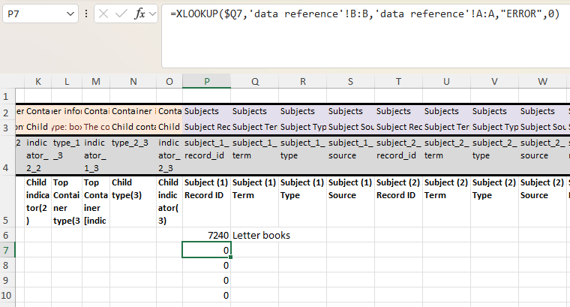
As you click into individual cells, notice how the cell references have or haven't changed. If a cell reference isn't referring to the cell(s) it ought to, update the cell reference in the formula in the first cell and re-fill the rest of the column.
Repeat these steps for the Subject Type and Subject Source columns, updating the formula so the return_array refers to the Type column and Source column on the Data reference tab, respectively.
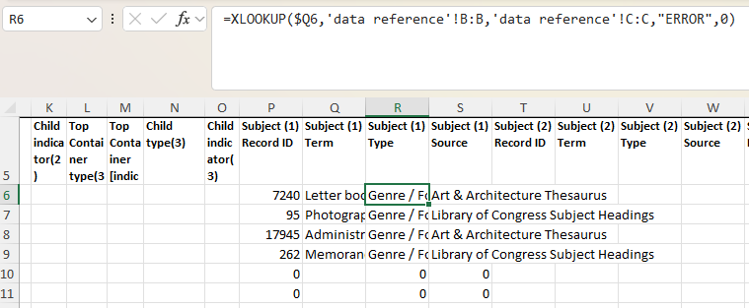
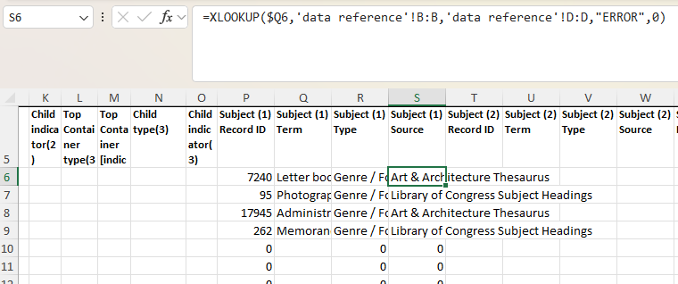
Then copy the formulas in these columns to the other subject columns as needed, being sure to double-check the cell references.

Proofing the Record ID, Type, and Source Columns
After terms have been assigned and the XLOOKUP functions have been coded, proof the results for any errors or cells that have returned the if_not_found value.
Also check for any records that should have genre/form terms assigned but were missed.
Also check for any cells that should be empty but aren't. This will most often occur for records that don't need all of the subject columns filled out—for instance, a file that has only two material types won't make use of a third a fourth set of subject columns. In these cases, the Subject Term column will be blank but the XLOOKUP formula will still be in place for the Record ID, Type, and Source columns (in these cases, it may display "0" or the if_not_found value). Simply delete the formula from these cells.
Conditional formatting can help to call attention to cells that have returned the if_not_found value (Format only cells that contain>Specific text>"[if_not_found value]"), records that have missed being assigned genre/form terms (Format only cells that contain>Blanks), and cells that should be blank but aren't (Format only cells that contain>Cell value>equal to>=0).

Copying Subject Metadata to the Import Spreadsheet
After genre/form terms have been assigned throughout the collection, the Record ID, Type, and Source columns have been coded to retrieve the corresponding information, and the cells have been proofed for errors or problems, it's time to copy the subject information from the Genreform tab to the import tab.
If you have duplicated all of the header rows from the import spreadsheet, copy the whole columns and paste over the columns in the import spreadsheet. If you haven't duplicated all of the header rows—if you just created your own simple header row, for example—copy everything except the header row(s) and paste it beginning in the first row after the headers in the import spreadsheet.
Be sure to paste just the values. Basic "paste" or "Ctrl+v" will paste the formulas, which will update all of the cell references, recalculate the data, and, eventually, break ArchivesSpace when you try to import. We want to copy and paste just the results of our formulas. There are three ways to paste just the values:
- Paste as usual then hit ctrl (or click on the paste menu) and select "Values only"
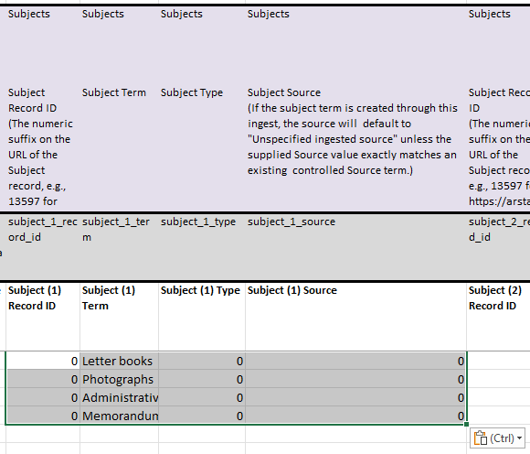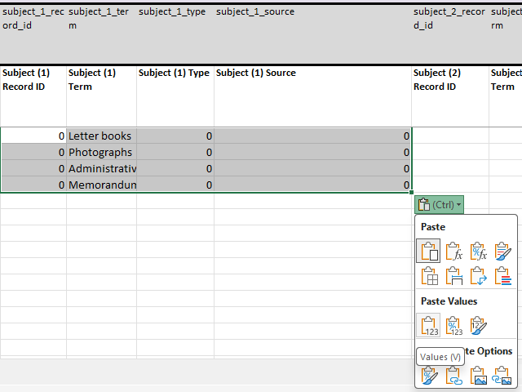
- Right click in the top-left cell destination and click "Paste Special" then select "Values only"
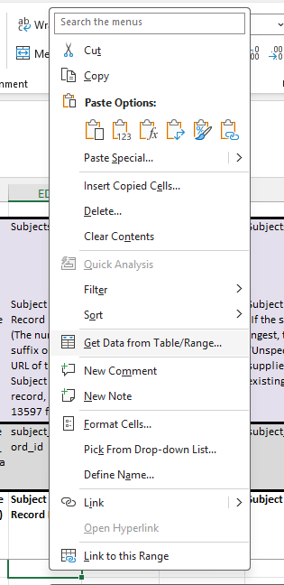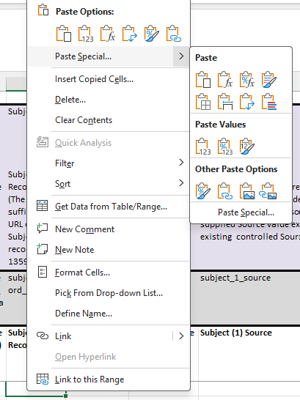
- Type ctrl+shift+v (instead of ctrl+v). This is the keyboard shortcut to paste values only.
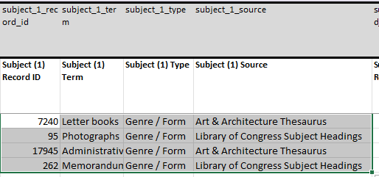

Before Import
If the tabs for assigning genre/form terms and coding the data validation were added as new tabs on the import spreadsheet, delete these tabs (or move them to a new spreadsheet file) before uploading the spreadsheet to ArchivesSpace.

Notes
The Notes section is color coded to group all of the fields together, and all are identified by the label "Notes" in the ArchivesSpace Resource record Section row.
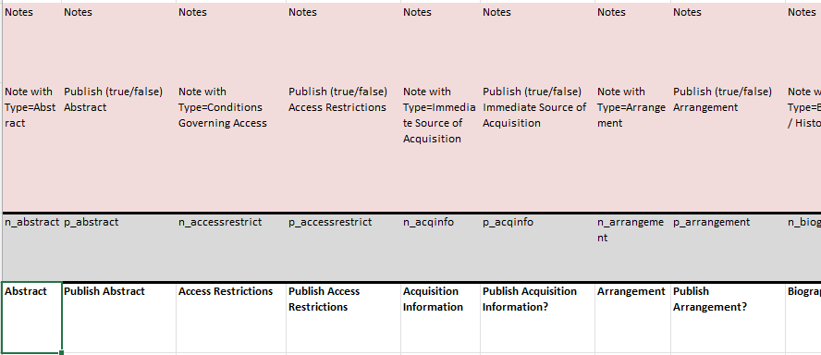
Note columns can be deleted or hidden as needed.
All of the notes are made up of two columns: the note body (identified in the ArchivesSpace Field code row by the prefix "n_" and the publish note setting (identified in the ArchivesSpace Field code row by the prefix "p_" and in the Field name row by the first word "Publish"). In every case, type the body of the note in the first column and TRUE (to publish the note) or FALSE (to not publish the note) in the second column. Most notes will be published. If you are adding a note, fill out both columns—never fill out just the note body or just the publish note setting.

Notes Most Commonly Used at the File and Item Level Include:

Access Restrictions
This is the equivalent of the Conditions Governing Access note. This note is used to draw attention to restricted materials, whether condition restricted or otherwise. Refer to the File and Item-level description documentation and/or the Series- and Subseries-level description documentation, as applicable, for guidance on when to include a Conditions Governing Access note and how to compose the note.
Note that, if there are restriction dates, you will have to add those manually in ArchivesSpace after import.
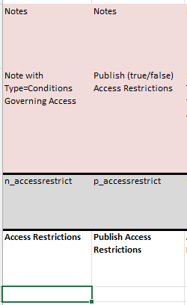

Biography/History
This note should be included whenever there is a creator linked to a record. Refer to the Biographical and Administrative histories documentation for further guidance on Biographical and Administrative History notes.
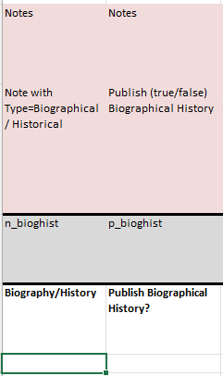

General
This is the equivalent of the General note. This field is usually used at the file or item level to state where the title came from, or to state an alternate title and its source. Refer to the File and Item-level description documentation for guidance on general notes at the file and item levels and the Series- and Subseries-level description documentation for guidance on general notes at the series and subseries levels.
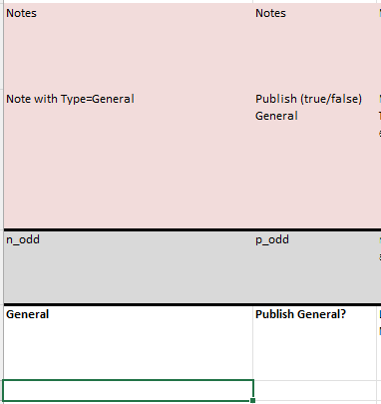

Language of Materials
This field maps to the Languages section of the finding aid where portions of languages found in the collection can be stated. Note that there are two ways of recording the language of materials: the drop-down list and the Language note. However, there is no space on the import spreadsheet to code for the Language drop-down list; all languages will need to be coded manually in ArchivesSpace. Further, as discussed in the Procedure Manual, a Language of Materials note should only be included when there are multiple languages present in the materials being described.
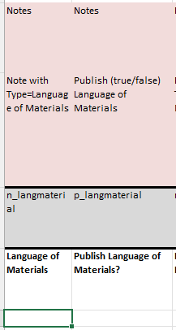

Scope and Contents
This is the equivalent of the Scope and Contents note. This is a commonly used note at file and item levels to mention extra information about the materials that cannot be captured in the title.
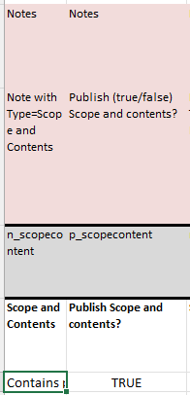

Other Notes Commonly Used at Series and Subseries Level:

Arrangement
Arrangement notes should be crafted following the guidelines in the Series- and Subseries-level description documentation.

Other Notes Not Usually Used in the Import Spreadsheet:
Acquisition Information, Custodial History, Processing Information, Related Materials, Separated Materials, and Use Restrictions are used at our institution but are usually utilized at the collection level.

Multiple Notes
If you need to repeat a note, you can use an unsued note field and we can ask the Metadata Standards Librarian to run an API to change the note label once the spreadsheet has imported.
You can also update the note type manually (at the same time as selecting ce/Gregorian). If updating manually, do not use the Abstract, Language, Physical Description, Physical Facet, or Physical Location notes, as these notes take a different format on ArchivesSpace.

Additional Resources
ArchivesSpace's GitHub provides additional documentation on the template spreadsheet here.

Upload to ArchivesSpace
Once your spreadsheet is complete, it will have to be fully tested on the staging server of ArchivesSpace and reviewed for metadata compliance by the Archival Processing Section before being uploaded to production.
To upload the spreadsheet, click "Load via Spreadsheet."
This will bring up the Load Spreadsheet dialog box.
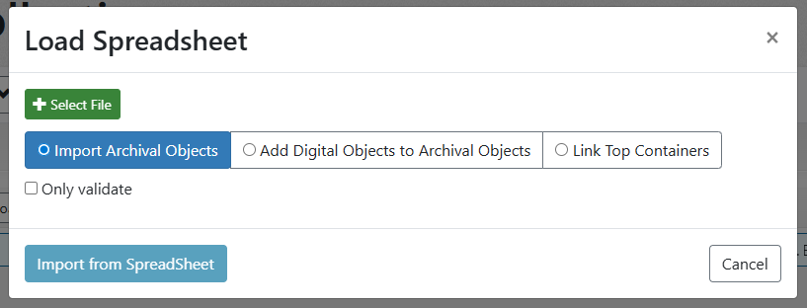
Click "Select File" and find and select your spreadsheet in your files. You are importing Archival Objects, so make sure that option is selected. Once your file is selected, click "Import from SpreadSheet."

